**Reset Multi-Factor Authentication (MFA)**

This SOP provides a detailed guide for administrators to reset Multi-Factor Authentication (MFA) for a specific Store Manager (SM) in certain situations. This action can only be carried out by higher authorities (admin).

**Process Overview:**

Resetting MFA for a particular Store Manager may be necessary in certain situations. Here are the step-by-step instructions for administrators to Reset MFA for a specific SM:

**Step1: Access the Admin Panel:**

-Log in to the system using your admin credentials to access the admin panel.

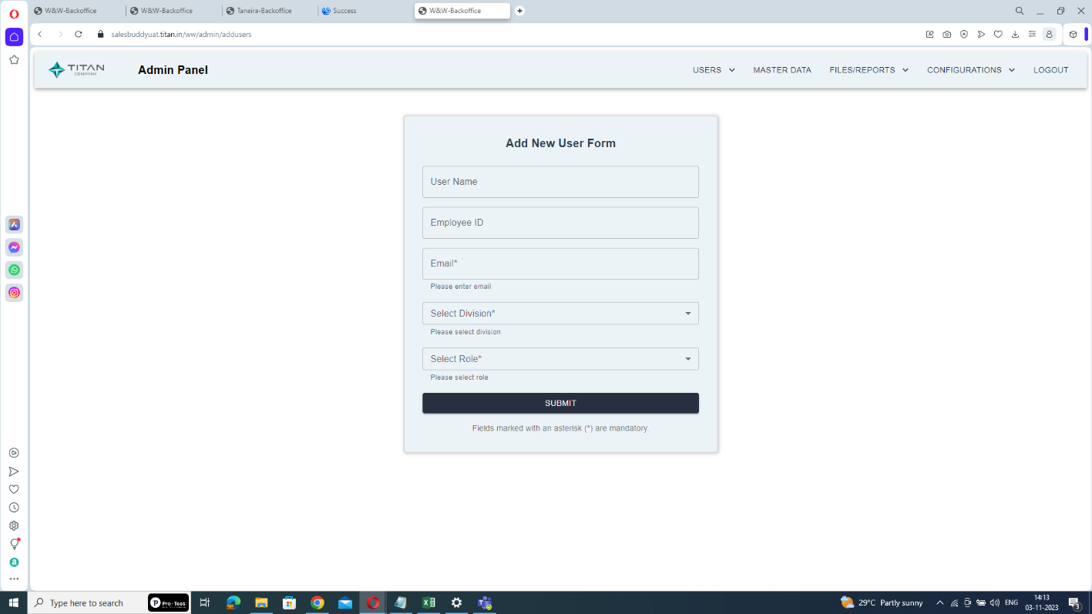

**Step2: Navigate to USERS:**

- Within the admin panel, locate and select the "USERS" section.

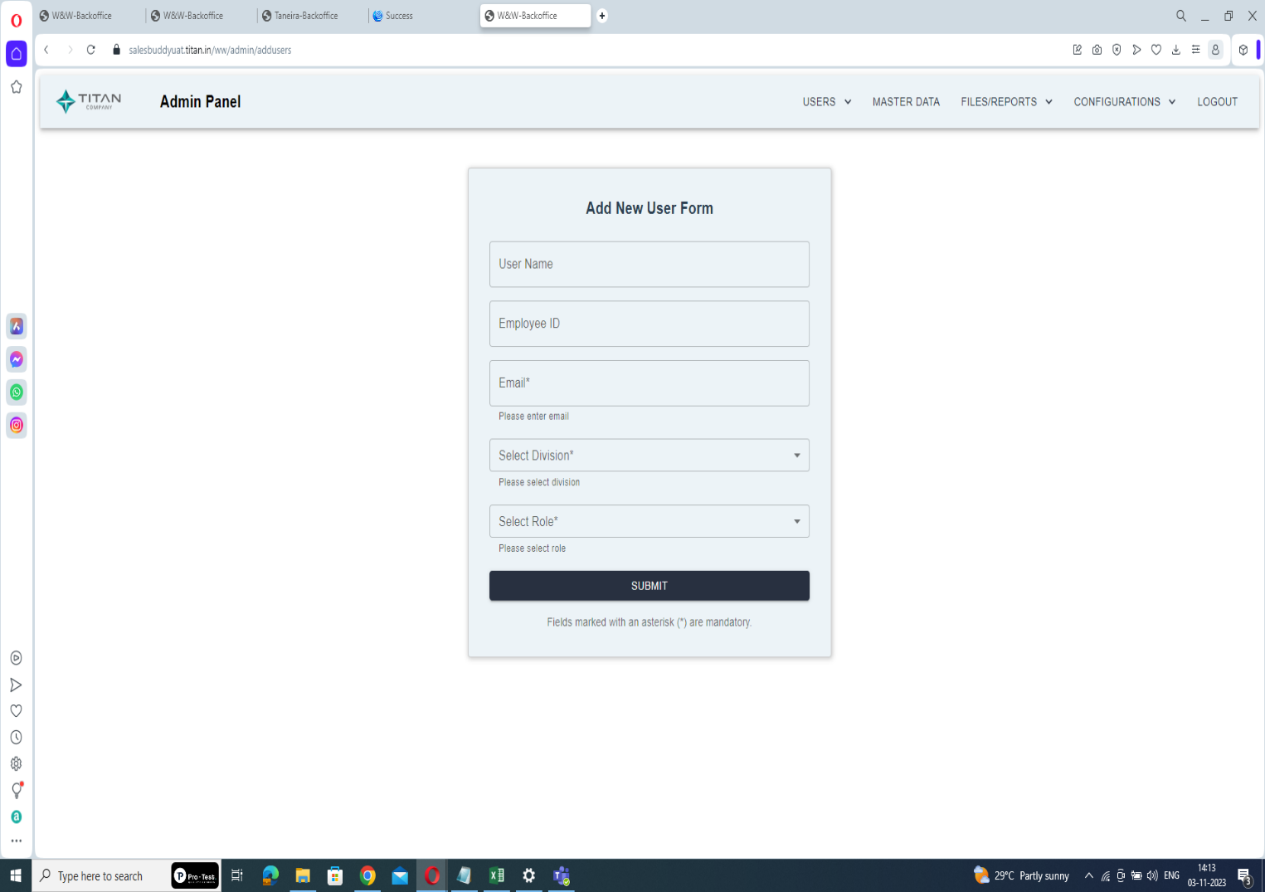

Click here

**Step3: Access View/Remove:**

- Within the Users section, find and click on "View/Remove".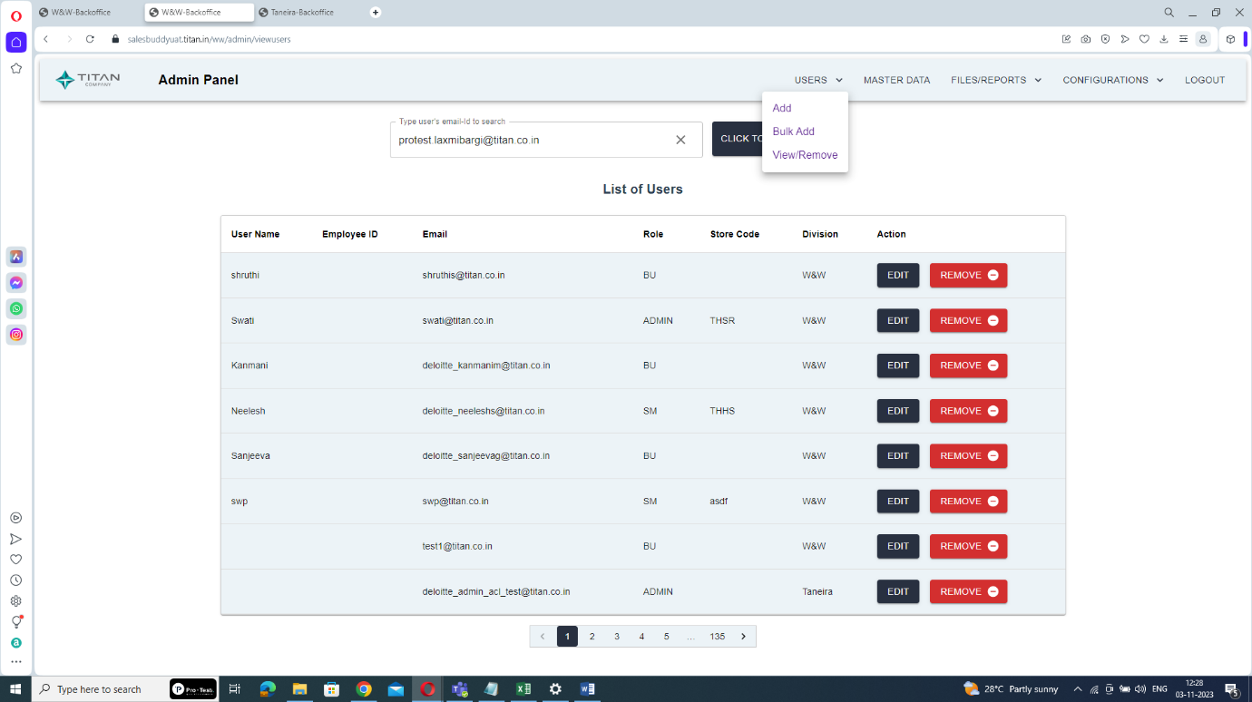

Click here

**Step4: Search for the User:**

- In the View/Remove section, you will find a search field. Type the email ID of the specific user (the Store Manager) for whom you want to reset MFA.

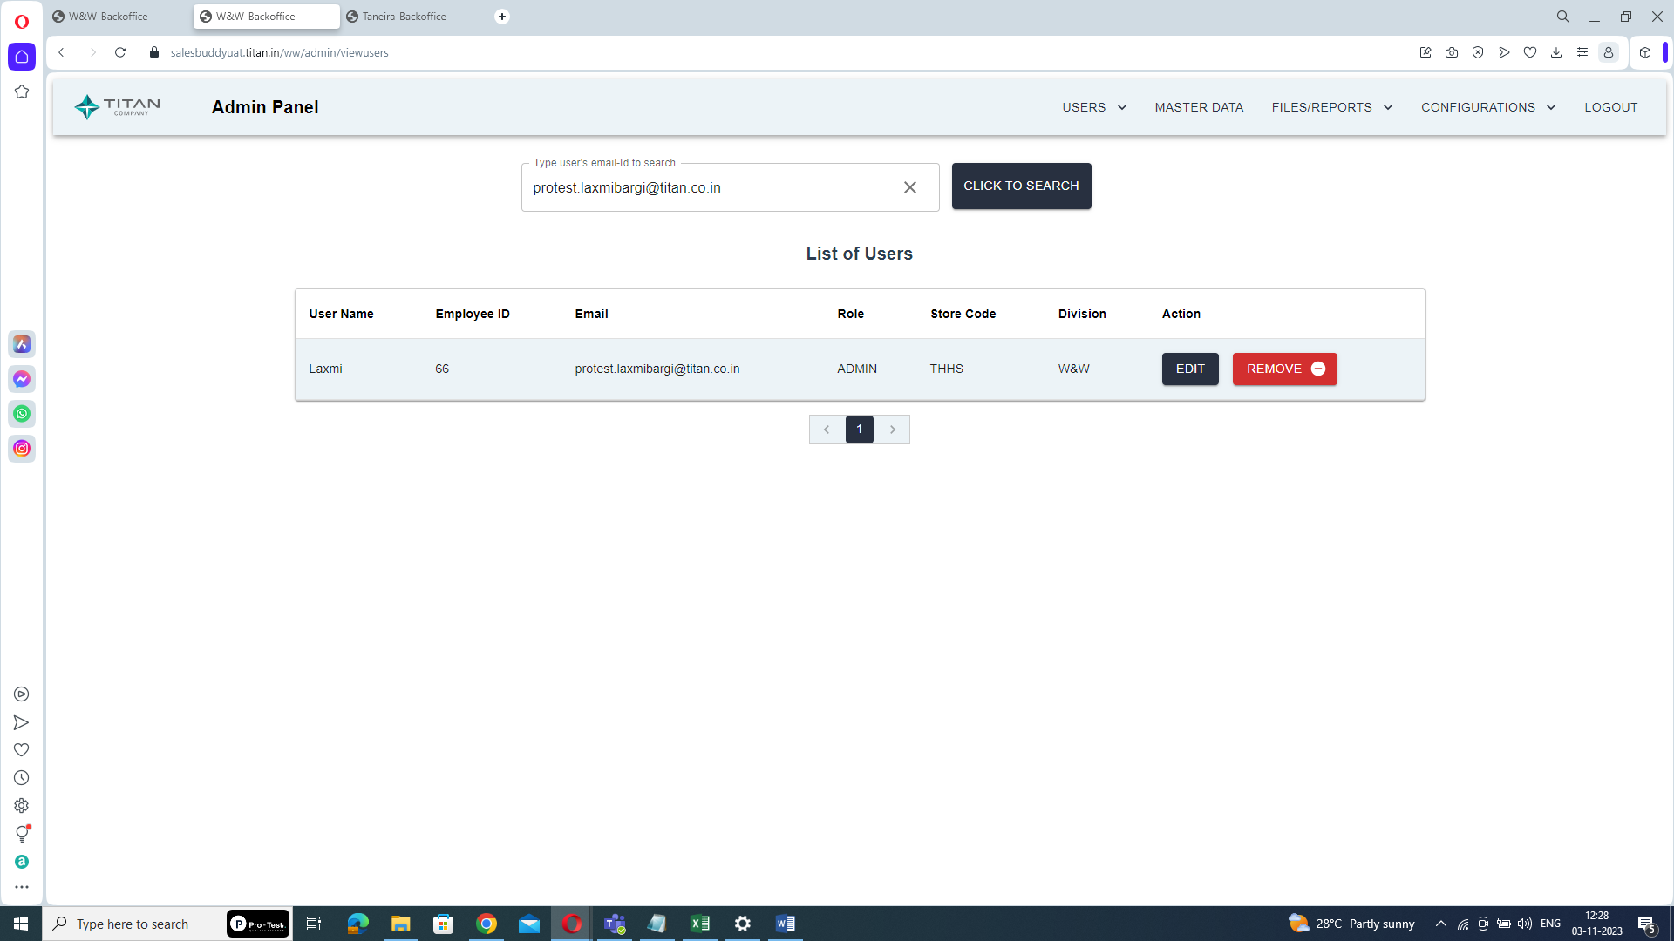

Enter user’s email-id

**Step5: Search for User:**

- Click the "CLICK TO SEARCH" button to find and display the user profile.



Click here

**Step6: Edit User Details:**

- Once you've located the user, click on the "EDIT" option next to their profile.



Click on EDIT

**Step7: Set Role as Store Manager:**

- In the user details editing page, select the user's role as "Store Manager".

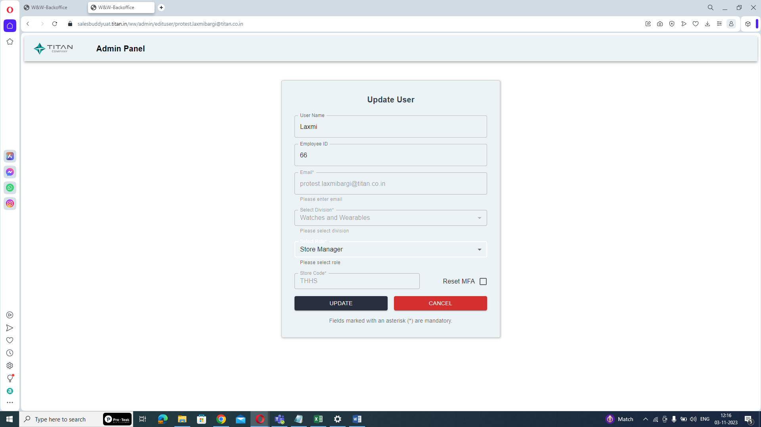

Select role as store manager

**Step8: Reset MFA:**

- After setting the role, locate the "Reset MFA" option, and click on it. This action will reset the multi-factor authentication for the selected Store Manager.



Click here

**Step 9: Save Changes:**

- After resetting MFA, click the "Update" button to save the changes to the user's profile.



Click here

Once MFA is reset for the specified Store Manager, the Store Manager will need to enroll in the multi-factor authentication process again when logging in, enhancing the security of their access.

By following these step-by-step instructions, administrators can effectively reset Multi-Factor Authentication for a specific Store Manager in situations where it is required.